STEVEN D. M. HILL

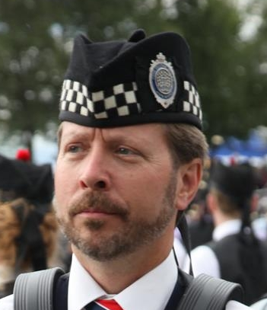
- Professional Solo Snare Drummer
- Certified PPBSO Drumming Judge – both Snare Drumming A and Ensemble A.
- Former lead drummer for of Grade 1 Scotsair Pipe Band, London Ontario.
- Competed with Grade 1 Pipe Bands: Scotsair, 78th Fraser Highlanders, Toronto Police and Peel Regional Police.
- Tuition available for all levels of solo competitors and drum corps. up to grade 2. On Line tuition also available.
- Workshops and score composing available.
- Currently active in the London, Ontario area.

Contact Information:
stevenerinhill@gmail.com
248 408-6444

